Kermit

The eighth English Song Festival “Kermit” was held in Pabianice Leisure Centre MOK on 23rd November 2012.

Our school was represented by:
- Agata Brzozowska, form 1Bi (teacher A. Krajewska)
- Sebastian Pełka, form 2I (teacher M. Kęcik)

Students were supposed to present their vocal abilities in two English songs, one of which had to concern ecology.

Agata Brzozowska performed:
“Walking on Sunshine” by Katrina & the Waves and “Once Upon
a December” by Deana Carter.

We are pleased to announce that Sebastian Pełka received an award for performing the “Earth Song” by M. Jackson and
“One More Night” by Maroon 5.

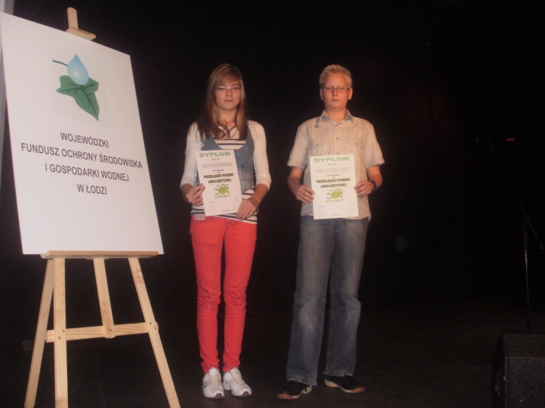

Mini-Saga

The literary competition Mini-Saga was held in December. Our school was represented by 11 students.
1.Julia Fijołek
2.Viktor van Wijngaarden
3Aleksandra Miller
4.Karolina Strózik
5. Michalina Sadowska
6.Agnieszka Zarzycka
7.Julia Warmńska
8.Magdalena Kukieła

The jury decided to award:
1st prize Viktor van Wijngaarden , form 1D (teacher M. Kęcik)
2nd prize Aleksandra Miller, form 2F (teacher A. Krajewska)

Congratulations !!!

Prepared by: AgnieszkaWitasik

